What Is E-Commerce?

From Your Instructor
What Are the Differences Between a Value Chain and SWOT?
The value chain, created by Michael Porter, is a business management concept that includes nine activities that work together to provide value to customers. When a company implements a value chain, it possesses a greater ability to generate profits. SWOT is a strategic planning method in business that allows a company to identify and analyze its strengths, weaknesses, opportunities and threats. SWOT analysis allows companies to evaluate internal and external factors and develop effective marketing plans. The value chain deals with several departments in a company, while SWOT is primarily analyzed by the marketing department.

Lesson Objectives
- Explain what electronic commerce is and its evolution in three waves of development.
- Explain why companies concentrate on revenue models and business process analysis instead of business models when they undertake electronic commerce initiatives.
- Identify opportunities for and barriers to electronic commerce initiatives.
- Analyze how economic forces have led to the development and continued growth of electronic commerce.
- Evaluate how businesses use value chains and SWOT analysis to identify electronic commerce opportunities.
- Describe how the international nature of electronic commerce affects its growth and development.

Lesson Requirements
- Read Chapter 1, “Introduction to Electronic Commerce.”
- Complete all tutorials and activities under Practice Activities.
- Complete the Lesson 1 Quiz (10 points).
- Complete the Lesson 1 Hands-On Project (30 points).
- CIS235
- E-COMMERCE
- Lesson 1: What Is E-Commerce?
- Connecting Your Learning
- Alana sat quietly at her desk, looking with a bit of puzzlement at her computer screen. She had just received an email from her boss Dave, director of the marketing department, that said "Please come and see me immediately." Moments later, Alana went to his office, and Dave broke out into a smile.
- "Come on in," Dave said, "and please don't look so worried. Alana, I noticed that you're trained in graphic arts and Web design. I'd like you to help with the creation of our company's e-commerce Web site. We need someone with your creative and artistic skills to make it look good. Right now, it's a bit ... well, ... blah, to say it kindly. It seems that blah and boring really aren't attracting customers or bringing quality sales our direction," he said.
- Alana thought for a moment and finally said, "Well, it sounds like an interesting adventure!"
- "Great," Dave replied, "you can start tomorrow morning!"
- Alana quickly interrupted, "But I have never worked with a shopping cart before, nor do I have any online marketing experience."
- Dave wasn't too concerned. "Alana, I've seen your work and I know that you always do your best. That's why I'm asking you to take on this task. If there is something you don't understand, you can always ask me, and we'll figure it out. Besides, I think it's a great chance to add some new skills to your résumé," he said.
- As you proceed through the course, you'll follow Alana as she learns about e-commerce and designs a Web site for her company. In this lesson, you will explore the history and key components of e-commerce in addition to how to create a wireframe. You'll also review HTML and CSS.
Readings, Resources, and Assignments
Required Reading | Chapter 1, "Introduction to Electronic Commerce"
Multimedia Resources | None
Required Assignments | Quiz  Hands-On Project
- Check Prior Knowledge
- Check your prior knowledge of concepts and key terms by completing the Concept Check game. You can play again at the end of the lesson.
- ACTIVITY LINK OUT
- Focusing Your Learning»
- 12% Progress
- ©2020, Rio Salado College. All Rights Reserved.
CIS235
E-COMMERCE

Lesson 1: What Is E-Commerce?

Focusing Your Learning

Lesson Objectives
By the end of this lesson, you should be able to:
- Analyze how economic forces have led to the development and continued growth of electronic commerce.
- Describe how the international nature of electronic commerce affects its growth and development.
- Evaluate how businesses use value chains and SWOT analysis to identify electronic commerce opportunities.
- Explain what electronic commerce is and its evolution in three waves of development.
- Explain why companies concentrate on revenue models and business process analysis instead of business models when they undertake electronic commerce initiatives.
- Identify opportunities for and barriers to electronic commerce initiatives.

Approach the Objectives
As you read Chapter 1 in your book, use the following tips to help you as you study the lesson material:
- Have VS Code and a Web Browser running on your PC in front of you as you read so you can try out any HTML code samples as well as any links mentioned in the assigned reading.
- Pay attention to the illustrations and tables, as they provide information designed to solidify concepts presented in the assigned reading.
- Take note of Figure 1-2 in the textbook, as it explains the differences between the categories of e-commerce.
- Focus upon the different waves of electronic commerce and the key happenings during the eras.
- Check out Figure 1-5, as it illustrates how some products are best suited for online sales while others require more of a traditional commerce environment.
- Take note of the Value Chain example (Figure 1-10) and SWOT Analysis (Figure 1-11).
- Pay special attention to "Trust Issues on the Web" on pages 39-40.

Define Key Terms
Review these key terms and definitions(opens in a new tab) before reading the lesson assignment to gain a greater understanding of lesson concepts.
«Connecting Your Learning
Creating a Wireframe»
25% Progress
©2020, Rio Salado College. All Rights Reserved.
CIS235
E-COMMERCE

Lesson 1: What Is E-Commerce?

Creating a Wireframe
During your related studies, you have probably seen, or maybe even created, a wireframe diagram for a Web site. In simple terms, a wireframe is a potential design / layout schematic that helps you visually place where the key elements of a Web site will appear on the screen.
For example, where should a company's logo appear on a new Web site? Should it be positioned at the top left side of the screen, or should it be located at the top center of the page? By utilizing a wireframe, you can quickly see how various design ideas will visually appear on the screen.
Consider the wireframe below. In many ways, it looks like a blueprint. Notice that it has a header section at the top of the page, plus an area to hold the page's navigation links. The main area of the body contains the core components of the Web site, which might provide information ranging from greeting visitors to telling them a bit about the products being offered. Notice at the bottom of the page that there is a footer section, which is a great place to provide copyright and contact info.
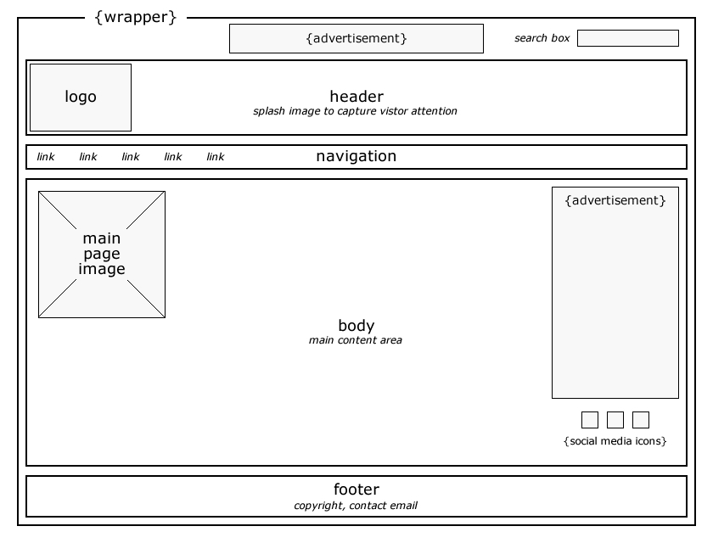
As a generalized rule, a Web site wireframe (think blueprint) should contain enough detail to clearly illustrate its essential features. The wireframe should show the placing of the various elements (e.g., the header, navigation links, body, footer, etc.), their approximate sizing, sample placeholder text (such as Lorem Ipsum(opens in a new tab)), and any additional features or details needed.
Some Web designers prefer to create very detailed wireframe schematics by specifying exact sizes and placement for all elements in the diagram. A good carpenter's adage describes this philosophy: "Measure twice, cut once." As your Web design skills grow, it is recommended that you include size measurements for components as well.
Typically, a wireframe is completed in black and white or grayscale and does not include styling components such as typography, color, or graphics since the primary purpose of the wireframe is to focus on layout, features, functionality, and priority or flow of content. Wireframes can be sketched using pencil and paper, drawn using a whiteboard, or a created with a graphics program such as Photoshop. They can even be created using mobile / tablet applications, such as Adobe Comp CC(opens in a new tab). NOTE: You don’t have to use Adobe Comp CC to complete your homework assignment.
(opens in a new tab) | Video: Adobe Comp CC With iPad Pro and Apple Pencil(opens in a new tab) (5:02)  This video gives a preview of creating a wireframe layout for a portfolio project using the Adobe Comp CC software for tablet devices.
«Focusing Your Learning
Use Case / Site Maps»
37% Progress
©2020, Rio Salado College. All Rights Reserved.
CIS235
E-COMMERCE

Lesson 1: What Is E-Commerce?

Use Case / Site Maps
A Use Case is a generic tool Web designers often utilize to visually document how customers will interact with a company's Web site. Check out the following video, which shows how this feature can easily be used to map out a site's structure.
Video: Use Case(opens in a new tab) (7:15)
This video demonstrates how to utilize a use case to visually document the different sections of a Web site.

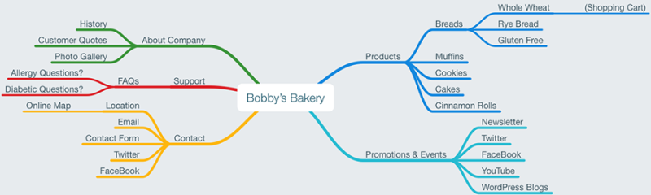
«Creating a Wireframe
HTML & CSS Review»
50% Progress
©2020, Rio Salado College. All Rights Reserved.
CIS235
E-COMMERCE

Lesson 1: What Is E-Commerce?

HTML & CSS Review
The expression "practice makes perfect" holds true for developing fluency and skill with Web design. The following PDF presentation and YouTube videos are designed as a refresher to review the beginning essentials of how to add and format text in HTML and CSS.
Chapter 1 - "Basic Text Essential for HTML"(opens in a new tab)

Video: Beginning Text Essentials for HTML - Part 1(opens in a new tab) (13:59)
This video reviews essential HTML tags for working with text.

Video: Beginning Text Essentials for HTML - Part 2(opens in a new tab) (16:02)
This video reviews essential CSS features for formatting text.

Tip: After you watch the videos, practice the concepts presented to ensure you can successfully demonstrate them!
«Use Case / Site Maps
Practicing Your Learning»
62% Progress
©2020, Rio Salado College. All Rights Reserved.
CIS235
E-COMMERCE

Lesson 1: What Is E-Commerce?

Practicing Your Learning
Video: What Is a Wireframe?(opens in a new tab) (5:09)
This video tutorial provides a visual explanation of the importance of using a wireframe.

Video: Developer's Toolbox: Brackets(opens in a new tab) (10:32)
This tutorial gives an excellent review of some of the best features available in the Adobe Brackets code editor.

Video: Creating a Site Map With Microsoft Word(opens in a new tab) (6:44)
Do you need a way to create a site map for a future Web site? Microsoft Word provides a SmartArt feature, which can be very handy for generating a Web site's sitemap.

«HTML & CSS Review
Assessing Your Learning»
75% Progress
©2020, Rio Salado College. All Rights Reserved.
CIS235
E-COMMERCE

Lesson 1: What Is E-Commerce?

Assessing Your Learning
The following are required for this lesson:
- Read Chapter 1, "Introduction to Electronic Commerce."
- Complete all tutorials and activities under Practice Activities.
- Complete the Lesson 1 Quiz (10 points).
- Complete the Lesson 1 Hands-On Project (30 points).

Quiz
The quiz consists of 10 questions made up of true/false items. Each question is worth 1 point.
Lesson 1 Quiz(opens in a new tab)

Hands-On Project
Using the assigned store theme you received in Lesson 0, complete the following:
- Complete the Hands-On Project by following the Lesson 1 Project Instructions.
- Place the following file(s) in a folder and label it "Lesson 01."
  - Wireframe (.jpg, .png, .doc, .docx, .pdf)
  - SWOT.doc (.docx)
  - SiteMap (.jpg, .png, .doc, .docx, .pdf)
- Zip the folder as described in the Syllabus.
- Submit the assignment, which is Lesson 1 Project(opens in a new tab) in the Gradebook.

IMPORTANT
If you ever forget which store theme you were assigned, you can obtain this information by visiting the Gradebook and reviewing the Hands-On Project Acknowledgment feedback link.
«Practicing Your Learning
Summarizing Your Learning»
87% Progress
©2020, Rio Salado College. All Rights Reserved.
CIS235
E-COMMERCE

Lesson 1: Project Directions

Hands-On Project
In this project, you will demonstrate your knowledge from Lesson 1 as you begin planning your Web site. There are 3 parts to this project:
- Wireframe (10pts.)
- SWOT Analysis (10pts.)
- Use Case / Site Map (10pts.)

Create a Web Site Wireframe (10 points)
Now that you know your assigned store theme, it’s time for you to develop a creative Web site layout proposal for it! Remember, this wireframe should reflect your own unique design. Using any graphic tool of your choosing, complete the following steps. (Acceptable ﬁle formats for homework submission are .jpg, .png, .doc, .docx, or .pdf.)
- Add the company name and a location for the company logo.
- Add areas for a header, body/content, and a footer.
- In the header section, include five category links pertaining to your project’s theme. (For example, if you were producing a site for a bakery, you might have categories such as breads, muffins, cookies, cakes, and cinnamon rolls.)
- Add image areas to your wireframe to advertise this week’s newest sale offers and products. Make it clear these areas are for product advertising.
- Add a minimum of one additional area to the page, such as company news, with an associated image and text description to go with it.
- In the footer section, include a link to customer support, company location, social media, and history about the company.
- Include your name, course, and section number in the wireframe so you can receive credit for this portion of the homework.
- Save the image as one of the acceptable file formats with the name Wireframe.
Example Wireframe:
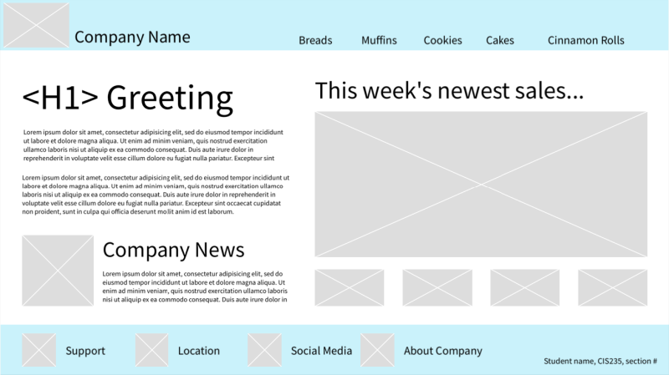
License: No known copyright restrictions

SWOT Analysis (10 points)
1. Perform a SWOT Analysis of your assigned company’s theme and create a document using Microsoft Word listing the company’s strengths, weaknesses, opportunities, and threats when it comes to e-commerce, as well as the reasons for each. Save as SWOT.docx.

Create a Use Case / Site Map (10 points)
- Using a program of your choosing, create an image (or a Microsoft Word document) that visually shows the structure/layout of the company’s future Web site. If you use Microsoft Word, utilize the Hierarchy feature in the SmartArt tool.
- Make sure to show the company’s name and at least four site categories, such as Products, Promotions, Support, and Company. Add subcategories to each category as they pertain to your assigned company theme.
- Save as SiteMap (with an acceptable file extension of choosing).

Submit Your Project
- When ready, save and submit the Wireframe, the SWOT analysis, and the SiteMap files to your course instructor for grading following the instructions in the lesson.
0% Progress
©2020, Rio Salado College. All Rights Reserved.
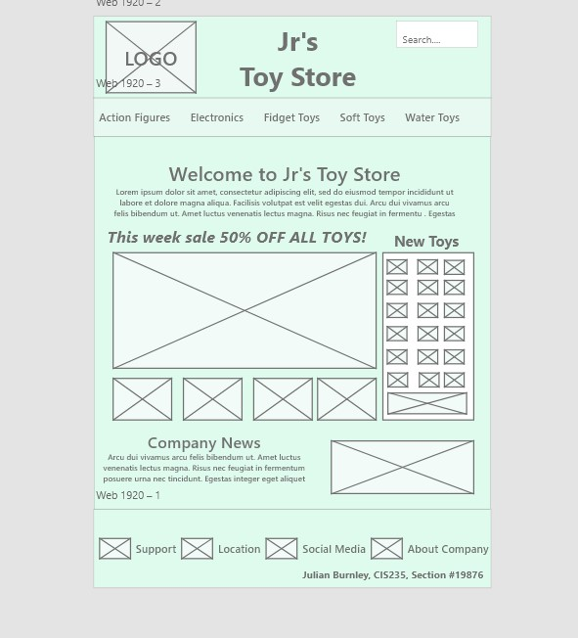

Jul2216252
CIS235
February 25, 2023

Perform a SWOT Analysis of your assigned company’s theme and create a document using Microsoft Word listing the company’s strengths, weaknesses, opportunities, and threats when it comes to e-commerce, as well as the reasons for each.
Jr’s Toy Store SWOT Analysis.
Strengths
The company’s main strength is its ability invest more on advertisement and discounts, instead of overhead costs a regular brick and mortar store has to pay, just to display their products to potential customers.
In the current environment, after COVID and the rise in violent crimes, parents have the time to research toys for their kids from the safety and comfort of their homes, at lower prices.
Weaknesses
Traditional toys have been overshadowed by electronic games, which run on consoles, with games that are developed for specific devices, and most recently online platforms. Many young people spend most of their time on these platforms, which are subscription based, allowing them a wide variety of games at relatively affordable prices.
Other online activities like social media and streaming platforms keep interest in traditional toys low.
Opportunities
Marketing and advertisements are more affordable and have more opportunities to reach more people, through social media, email, and advertisement banners.
People are spending more and more time online, allowing them exposure to products.
Data mining and tracking cookies also help with visibility. Most people like to shop around for better deals, saving time that would have been spent driving around.
Threats
As the pandemic wanes, people are looking to get out and do stuff. Toys that encourage exercising like bikes, and other outdoor activities are taking potential customers away from their computer screens.
Retail stores are catching up with the price cuts. Many have excess inventories they are willing to auction off.
Rising awareness about the negative health effects of a sedentary lifestyle are also getting potential customers away from their computer screens.
Assessment Feedback
Thank you for your participation in this assignment. Your work has been submitted to your instructor.
Total score: 10 out of 10, 100%
Question Feedback

Question
1 of 10
Since 2013, China has been the leader in online retail sales, with a growing proportion of those sales being made on smartphones rather than computers.
True
False

1 out of 1
Correct!!

Question
2 of 10
C2C refers to individuals who buy and sell items among themselves.
True
False

1 out of 1
Correct!!

Question
3 of 10
In the second wave of electronic commerce, mobile commerce finally took off with the increasingly widespread use of mobile phones that allow Internet access.
True
False

1 out of 1
Correct!!

Question
4 of 10
More than 5,000 Internet startup firms went out of business or were acquired in the downturn that began in 2000.
True
False

1 out of 1
Correct!!

Question
5 of 10
The First Wave of electronic commerce was well known for its vast improvement in high-speed broadband connections, which allowed consumers to watch large audio and video files.
True
False

1 out of 1
Correct!!

Question
6 of 10
Electronic commerce began in China.
True
False

1 out of 1
Correct!!

Question
7 of 10
The term electronic commerce refers only to the shopping part of the Internet called the World Wide Web.
True
False

1 out of 1
Correct!!

Question
8 of 10
Electronic commerce had humble beginnings in the early 2000s.
True
False

1 out of 1
Correct!!

Question
9 of 10
B2C is a term that means business-to-corporation.
True
False

1 out of 1
Correct!!

Question
10 of 10
The formal practice of accounting, or recording business transactions, dates back no further than the past 100 years.
True
False

1 out of 1
Correct!!
CIS235
E-COMMERCE

Lesson 1: What Is E-Commerce?

Summarizing Your Learning

Now that you have finished the reading and the practice and review activities, play the Lesson Concept Check game again to see how much you have learned.
ACTIVITY LINK OUT
«Assessing Your Learning
100% Completed
©2020, Rio Salado College. All Rights Reserved.

